SUBJECT: MATH CLASS: VIII
TERM II: TALES BY DOTS AND LINES

DAY - 1

The Balancing Act
Recall that the mean of some data is the sum of all values divided by the number of values. The median is the middle value when data is sorted.
- Concept: Understanding mean as a "balance point" rather than just a formula.
- Activity: Consider numbers 3 and 7. Their average is $\frac{3+7}{2}=5.$
- Visual Integration:
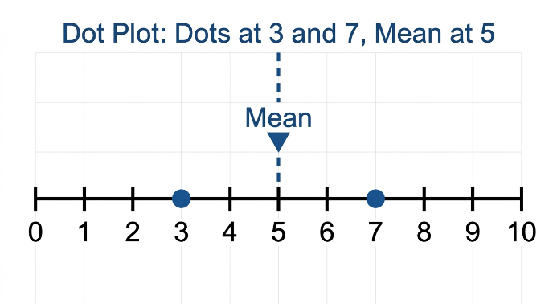
- Formative Assessment: Find the average of 8 and 9. Mark it on a dot plot.

DAY - 2

Mean as the Center of Distances
The mean represents the 'center' of the data because the total distances are equal on both sides of it.
- Token/Distance Model: For the collection 6, 7, 8, the mean is 7.
  - LHS distance (7-6) = 1.
  - RHS distance (8-7) = 1.
- Complex Balance: For data 2, 4, 9, the mean is 5.
  - LHS: (5 - 2) + (5 - 4) = 3 + 1 = 4.
  - RHS: (9-5) = 4.
- Visual Integration:
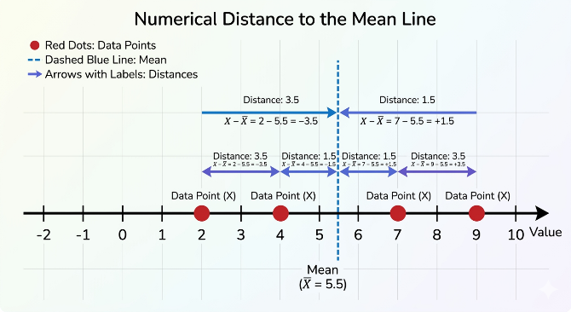
CW: Verify this distance balance for the collection 10, 10, 11, 17.

DAY - 3

Tinkering with the Mean
What happens to the "balance" when we add or remove values?.
- Rules of Change:
  - Include a value greater than the mean $→$Mean increases.
  - Include a value smaller than the mean $→$ Mean decreases.
  - Include a value equal to the mean $→$ Mean stays the same.
- Activity: Try to include 2 values greater than the mean and 1 value less than the mean so that the mean remains unchanged.
- CW: Pg 105 - Verify the "Unchanging Mean" collection.

DAY - 4

Algebraic Shifts in Mean
Exploring what happens when every value in a collection is modified by a fixed number.
- Addition/Subtraction: If every value x increases by 10, the new mean increases by 10.
- Algebraic Proof: $\frac{{(x}_{1}+10)+(x_{2}+10)...(x_{n}+10)}{n} = a + 10.$
- Multiplication: If every value is doubled, the average also doubles.
- HW: Explain using algebra what happens if 2 is subtracted from every value.

DAY - 5

Tinkering with Median
The median is the middle value—there are an equal number of values less than it and greater than it.
- Impact of New Data:
  - Include value > median $→$ Median increases.
  - Include value < median $→$$ Median decreases.
- Example: Data 3, 5, 7, 9, 11, 13 (Median = 8). If we add 11, the new median is the average of 8 and 11 (9.5).
- CW: Pg 114 - Q5 (i, ii, iii).

DAY - 6

Mean and Median with Frequencies
When data repeats, we use frequencies to find the "center" more efficiently.
- Weighted Mean: $Average =\frac{\left(Sum of Values\right)×Frequency}{Total Frequency}.$
- Finding Median from Tables: Successively add frequencies (cumulative) until you reach the middle positions (e.g., the 18th and 19th values for 36 total entries).
- Visual Integration:
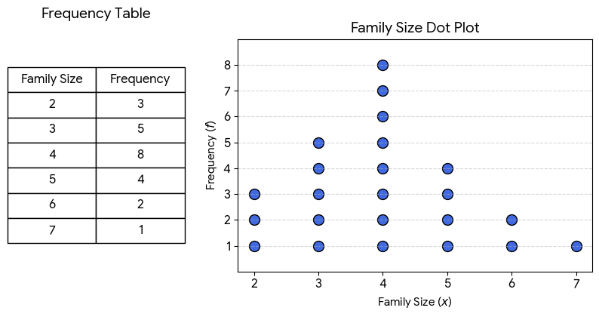
- HW: Calculate the median family size for the table on Pg 110.

DAY - 7

Spreadsheets: Digital Tools for Data
Computers use spreadsheets (cells in rows and columns) to perform calculations quickly.
- Cell Referencing: Cells are named by Column (A, B, C) and Row (1, 2, 3). Example: E5.
- Formulae:
  - =SUM(B3:G3) for totals.
  - =AVERAGE(B7:D7) for means.
- Activity: Use the QR code on Pg 113 to access the dataset on a computer.

DAY - 8

Visualising Change: Line Graphs
Line graphs are generally used to visualise data across time by connecting data points with line segments.
- Interpreting Slopes: A steeper line indicates a greater increase.
- Distinguishing Data: Different markers (circles, squares) help distinguish lines in greyscale or for those with color vision deficiency.
- CW: Pg 116 - Q10 (i, ii).

DAY - 9

Infographics and Patterns
Infographics communicate information clearly and quickly in a visually appealing way.
- Case Study: Wheat vs. Rice: Using a color scale to show consumption preferences across India.
- The "Red Line" Split: Identifying geographical divides in data patterns.
- Visual Integration:
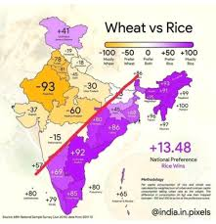
- Activity: Guess the preference value for Karnataka based on the surrounding states.

DAY - 10

Data Stories: Sleep and Daily Activity
Data can capture patterns in biological and social behaviors.
- Activity Strips: Using a strip of 48 boxes (30-min intervals) to record a 24-hour day.
- Biological Trends: Sleep duration changes with age—high for infants, decreasing in adulthood, and increasing slightly after age 50.
- Final Project: Create your own activity strip for a weekday vs. a vacation day.

PAGE – 127
CW – Q1, Q3, Q6, Q8, Q11, Q14
HW – Q2, Q4, Q5, Q7, Q9, Q10, Q12, Q13, Q15
PAGE – 122
CW – Q1, Q3
HW – Q3
PAGE - 113
CW – Q1 – I , Q2, Q3, Q5, Q7, Q11
HW – Q1 – II , III , Q4, Q6, Q8, Q9, Q10

